Практична робота №3

Тема: Статичний сюжетний малюнок

Виконав: (Куліш Ілля)

КОД:
using System;
using System.Drawing;
using System.Drawing.Drawing2D;
using System.Windows.Forms;

namespace SceneDrawing
{
public class SceneForm : Form
{
public SceneForm()
{
this.Text = "Сюжетний малюнок — Пейзаж";
this.Size = new Size(800, 600);
this.StartPosition = FormStartPosition.CenterScreen;
this.DoubleBuffered = true;
}

protected override void OnPaint(PaintEventArgs e)
{
base.OnPaint(e);
Graphics g = e.Graphics;
g.SmoothingMode = SmoothingMode.AntiAlias;

DrawScene(g);
}

private void DrawScene(Graphics g)
{
using (SolidBrush skyBrush = new SolidBrush(Color.FromArgb(135, 206, 235)))
{
g.FillRectangle(skyBrush, 0, 0, 800, 420);
}

using (Pen skyPen = new Pen(Color.SteelBlue, 2))
{
g.DrawRectangle(skyPen, 0, 0, 799, 419);
}

using (Pen sunPen = new Pen(Color.Orange, 3))
using (SolidBrush sunBrush = new SolidBrush(Color.Yellow))
{
g.FillEllipse(sunBrush, 640, 40, 100, 100);
g.DrawEllipse(sunPen, 640, 40, 100, 100);
}

using (Pen rayPen = new Pen(Color.Gold, 2))
{
rayPen.DashStyle = DashStyle.Dash;
int cx = 690, cy = 90;
int[] angles = { 0, 45, 90, 135, 180, 225, 270, 315 };
foreach (int angle in angles)
{
double rad = angle * Math.PI / 180;
int x1 = cx + (int)(55 * Math.Cos(rad));
int y1 = cy + (int)(55 * Math.Sin(rad));
int x2 = cx + (int)(80 * Math.Cos(rad));
int y2 = cy + (int)(80 * Math.Sin(rad));
g.DrawLine(rayPen, x1, y1, x2, y2);
}
}

using (Pen cloudPen = new Pen(Color.White, 1))
using (SolidBrush cloudBrush = new SolidBrush(Color.White))
{
DrawCloud(g, cloudPen, cloudBrush, 100, 80);
DrawCloud(g, cloudPen, cloudBrush, 350, 60);
}

using (Pen mountainPen = new Pen(Color.DarkSlateGray, 2))
using (SolidBrush mountainBrush = new SolidBrush(Color.SlateGray))
using (SolidBrush snowBrush = new SolidBrush(Color.White))
{
Point[] mountain1 = {
new Point(0, 420),
new Point(150, 150),
new Point(300, 420)
};
g.FillPolygon(mountainBrush, mountain1);
g.DrawPolygon(mountainPen, mountain1);

Point[] snow1 = {
new Point(150, 150),
new Point(120, 230),
new Point(180, 230)
};
g.FillPolygon(snowBrush, snow1);

Point[] mountain2 = {
new Point(200, 420),
new Point(370, 200),
new Point(520, 420)
};
g.FillPolygon(new SolidBrush(Color.DimGray), mountain2);
g.DrawPolygon(mountainPen, mountain2);

Point[] snow2 = {
new Point(370, 200),
new Point(345, 270),
new Point(395, 270)
};
g.FillPolygon(snowBrush, snow2);

Point[] mountain3 = {
new Point(450, 420),
new Point(580, 250),
new Point(720, 420)
};
g.FillPolygon(new SolidBrush(Color.Gray), mountain3);
g.DrawPolygon(mountainPen, mountain3);
}

using (Pen groundPen = new Pen(Color.DarkGreen, 3))
using (SolidBrush groundBrush = new SolidBrush(Color.ForestGreen))
{
g.FillRectangle(groundBrush, 0, 420, 800, 180);
g.DrawLine(groundPen, 0, 420, 800, 420);
}

using (Pen roadPen = new Pen(Color.DarkGray, 40))
{
g.DrawLine(roadPen, 400, 420, 400, 600);
g.DrawLine(roadPen, 200, 600, 600, 600);
}

using (Pen markingPen = new Pen(Color.White, 3))
{
markingPen.DashStyle = DashStyle.Dash;
g.DrawLine(markingPen, 400, 430, 400, 600);
}

using (Pen housePen = new Pen(Color.SaddleBrown, 2))
using (SolidBrush wallBrush = new SolidBrush(Color.Wheat))
using (SolidBrush roofBrush = new SolidBrush(Color.Firebrick))
{
g.FillRectangle(wallBrush, 80, 340, 130, 100);
g.DrawRectangle(housePen, 80, 340, 130, 100);

Point[] roof = {
new Point(65, 345),
new Point(145, 280),
new Point(225, 345)
};
g.FillPolygon(roofBrush, roof);
g.DrawPolygon(new Pen(Color.DarkRed, 2), roof);

using (Pen doorPen = new Pen(Color.Brown, 2))
using (SolidBrush doorBrush = new SolidBrush(Color.BurlyWood))
{
g.FillRectangle(doorBrush, 125, 390, 30, 50);
g.DrawRectangle(doorPen, 125, 390, 30, 50);
}

using (Pen winPen = new Pen(Color.SkyBlue, 2))
using (SolidBrush winBrush = new SolidBrush(Color.LightCyan))
{
g.FillRectangle(winBrush, 88, 355, 40, 35);
g.DrawRectangle(winPen, 88, 355, 40, 35);
g.DrawLine(winPen, 108, 355, 108, 390);
g.DrawLine(winPen, 88, 372, 128, 372);
}
}

using (Pen trunkPen = new Pen(Color.SaddleBrown, 8))
using (Pen leafPen = new Pen(Color.DarkGreen, 2))
using (SolidBrush leafBrush = new SolidBrush(Color.LimeGreen))
{
g.DrawLine(trunkPen, 580, 420, 580, 310);
g.FillEllipse(leafBrush, 540, 270, 80, 70);
g.DrawEllipse(leafPen, 540, 270, 80, 70);
g.FillEllipse(leafBrush, 520, 295, 70, 60);
g.FillEllipse(leafBrush, 570, 285, 75, 65);
}

using (Pen riverPen = new Pen(Color.DeepSkyBlue, 15))
{
riverPen.StartCap = LineCap.Round;
riverPen.EndCap = LineCap.Round;
Point[] river = {
new Point(650, 420),
new Point(620, 460),
new Point(660, 490),
new Point(630, 530),
new Point(670, 580),
new Point(800, 580)
};
g.DrawCurve(riverPen, river, 0.5f);
}

using (Font font = new Font("Arial", 10, FontStyle.Italic))
using (SolidBrush textBrush = new SolidBrush(Color.DarkGray))
{
g.DrawString("Пейзаж © C# Graphics", font, textBrush, 10, 570);
}
}

private void DrawCloud(Graphics g, Pen pen, SolidBrush brush, int x, int y)
{
g.FillEllipse(brush, x, y + 20, 70, 50);
g.FillEllipse(brush, x + 25, y, 60, 55);
g.FillEllipse(brush, x + 55, y + 15, 75, 55);
g.FillEllipse(brush, x + 15, y + 35, 100, 35);
}

[STAThread]
static void Main()
{
Application.EnableVisualStyles();
Application.SetCompatibleTextRenderingDefault(false);
Application.Run(new SceneForm());
}
}
}
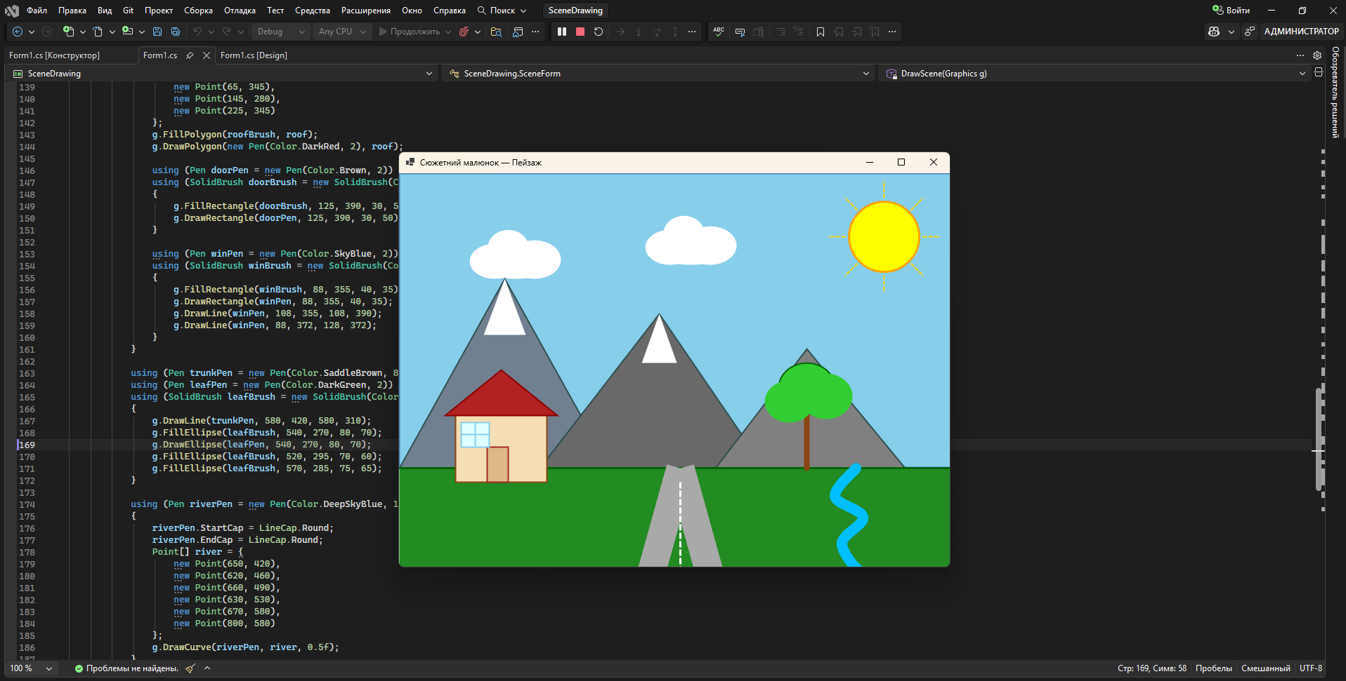

ВИСНОВОК:
У ході виконання практичної роботи була розроблена програма на мові C# з використанням Windows Forms та бібліотеки GDI+. Реалізовано статичний сюжетний малюнок — пейзаж з горами, будинком, деревом та річкою. Використано 5 різних графічних примітивів: прямокутник, еліпс, полігон, лінія і крива. Застосовано 6 різних олівців (Pen) з різними кольорами, товщинами та стилями штриху (суцільний, пунктирний). Вивчено принципи роботи класу Graphics та метод OnPaint у Windows Forms.

